Algorithms

Lab 4

Jacob Barcelona

In Lab 4 we were told to solve the traveling salesman problem once again, but this time we were to use a Genetic Algorithm and Tabu Search. Whilst in the last lab DP and Brute Force were inefficient for large sets, they obtained an objectively best answer. GA and Tabu because of how robust they are are not ideal for smaller sets of numbers, but scale extremely well.

The Genetic Algorithm is a metaheuristic technique that is is broken into three parts; Selection, Crossover, and Mutation. For selection I wanted to add randomness to have a better chance of improving results, while also maintaining the best paths. To do this I selected one parent with roulette wheel and one with elitism. For my roulette wheel, I made the fitness value for a path 1/cost as this would ensure the shortest paths have a higher probability of getting selected. Then I assigned a probability to each path in the population based on the fitness/total fitness of the population. Then a path is “randomly”(based on the probabilities) selected. After selection is performed both parents are crossed over to produce a child. I toyed with two crossover techniques, one-point and multi-point. Essentially both select a random point on the path and take parent 1’s genetic information up to the crossover point and parent 2’s genetic information past the crossover point. The difference with multi-point is that two crossover points are selected.The final part of GA is the mutation. I set the mutation rate at 4% and tried a rotate and swap mutation. You want a lower mutation rate because if the mutation rate is too high, you might as well be randomly picking the population as the genetic information will become so jumbled. Rotate mutation shifts each node to the right, making the last node the first node. Swap mutation swaps two randomly selected values in the path.

Below are the learning curves for the GA. There were four different configurations for GA. THe selection remained constant with one parent being selected by elitism and one parent being selected by rouletteWheel. Doing any other configuration hindered learning significantly. The four configurations were as follows: multi-point-crossover with swap mutation, single-point-crossover with swap mutation, multi-point-crossover with rotate mutation, and single-point-crossover with rotate mutation. The most significant result from this graph is that the best configuration is multi-point-crossover with swap mutation. I believe this is the case because multi-point-crossover retains more genetic information from the best of the population as parent 1 which is chosen using elitism has about twice the amount of information used in child as parent 2 like this illustration. In this case child is the path on the top left. The green is parent 1 and the blue is parent 2.

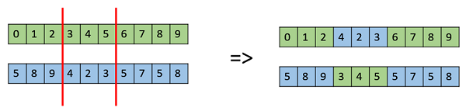

More of parent 1's information is in each child so better scores end up being achieved. It also seems that there is very little difference between the mutations in execution. All Genetic Algorithms were run for 10 minutes with a population size of 20. I picked 20 for the population size as after experimentation that seemed to be the “sweet spot” where there was an improvement over the generations. If the population was too big the algorithm converged on a solution too quickly making it no better than random, if the population was any smaller than 20, not enough genetic diversity was in every population.

X-AXIS(FITNESS SCORE) Y-AXIS(ITERATIONS PERFORMED)

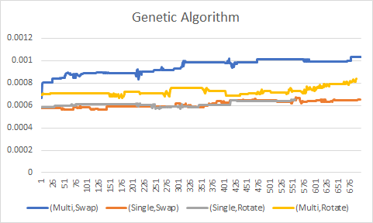

The Tabu Search selects a path from a “neighborhood” of paths defined by certain conditions. It uses a very similar selection technique to roulette wheel in GA. The three neighborhoods were every possible swap, every possible double swap, and a random shuffle. In execution I used half swap, half double swap, and had the random shuffle execute 4% of the time. The thought behind this was I saw the Search getting stuck in local minimums, so every once in a while a completely random path would generate so the algorithm can search for neighborhoods in unexplored solution space. This did improve my overall fitness scores, but the Tabu Search even after many alterations did not achieve fitness scores as high as the GA. Below are the Learning curves for Tabu Search using different Tabu List sizes. Each was run for 10 minutes with 100 nodes. Numbers lower than 100 nodes weren’t included because the learning was extremely fast for the lower number of nodes during a 10 minute period.

X-AXIS(FITNESS SCORE) Y-AXIS(ITERATIONS PERFORMED)

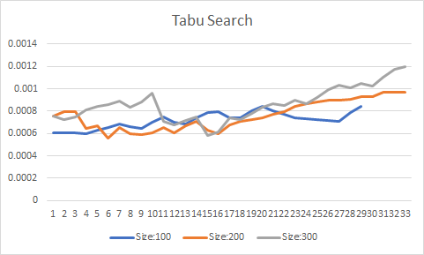

The obvious thing to note from these learning curves is that as you increase the tabu list size, the score the algorithm achieves is better. This is probably because it can search a more diverse solution space if there are more spots it can’t go back to. Another insight is that the “learning” is much more incremental in Tabu Search than in GA. GA had more plateau’s and sharp inclines, while Tabu was more incremental. This is probably because the searching space in much less diverse in Tabu and you aren’t using good solutions to hopefully make better solutions, you are just exploring the neighbors of each good solution and its neighbors will usually have the same or a slightly better or worse score.There is much less of a chance for a drastic change unless you have a random shuffle or a lucky swap.

For timing the two different algorithms performed very differently.

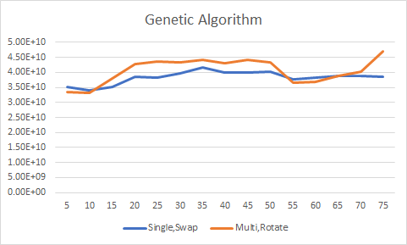

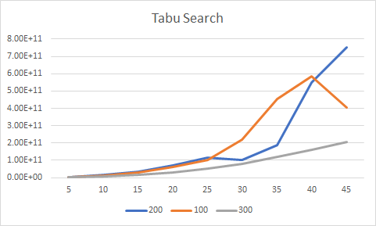

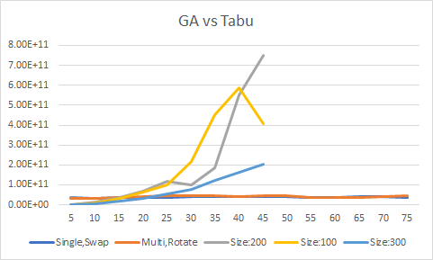

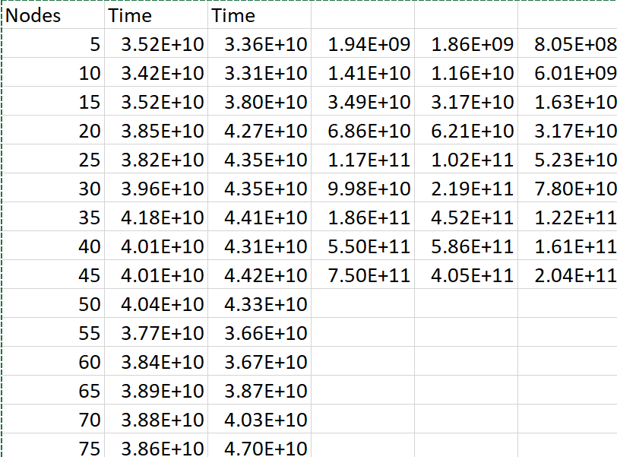

For GA the timing did not increase as the amount of nodes increased. Therefore, the time complexity is O(1) for each evolution of the population, because all of the operations done on the cities are done once per path. A time complexity of the entire algorithm would be O(1)\*number of times executed because you can set the number of times executed in the algorithm.

For the Tabu Search it’s timing is much more similar to the algorithms from Lab 3. It still increases based on the amount of nodes evaluated. The curious thing is that as the Tabu List size increases, the algorithm becomes faster. I am honestly not quite sure why this happens, but I assume it is because as the Tabu List size increases the amount of solution space and subsequent neighbors to search decreases. The time complexity for this algorithm is complicated as is uses three neighborhood identification techniques. A single swap which is O(n^2), a double swap which is O(n log(n-1)), and a random shuffle which is O(1). Depending on how you use the techniques the timing can change. And again whatever the time complexity is, it is multiplied by the amount of times you run it. The overall algorithm is still O(1) for each Run as

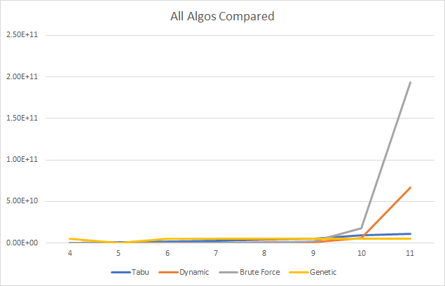

Above is a graph of all the timing of the algorithms from Lab 3 compared to algorithms from this lab. Before I talked about the timing for the GA vs Tabu and the same still holds for that. The main thing to note when comparing these algorithms to Dynamic and Brute force is they scale much better. In Lab 3 Dynamic and Brute Force only got to 11 nodes before the timing was too long. Tabu takes longer for more nodes, but because it’s swap function is O(n^2) it scales much better than Dynamic’s O(n^2\*2^n) and Brute Force’s (n!). To add to that, Genetic run in constant time O(1), so the amount of nodes barely affects the algorithms timing. If you need to know the exact answer in a TSP problem Dynamic is probably your best bet, but if not the Genetic Algorithm is by far a better answer as it gets a fairly good cost in a fraction of the time.

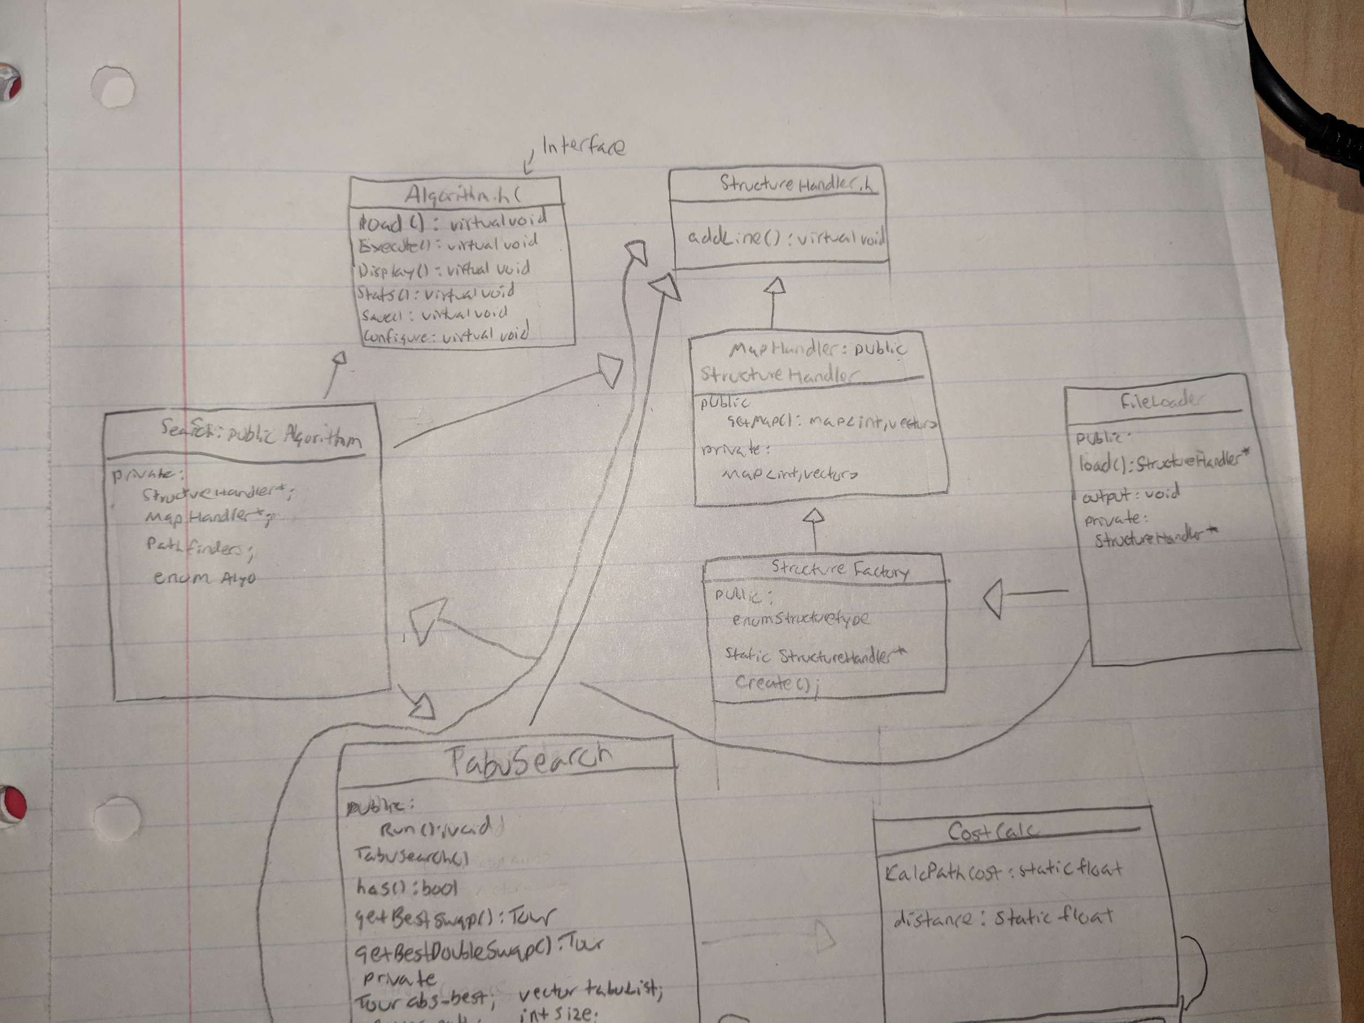

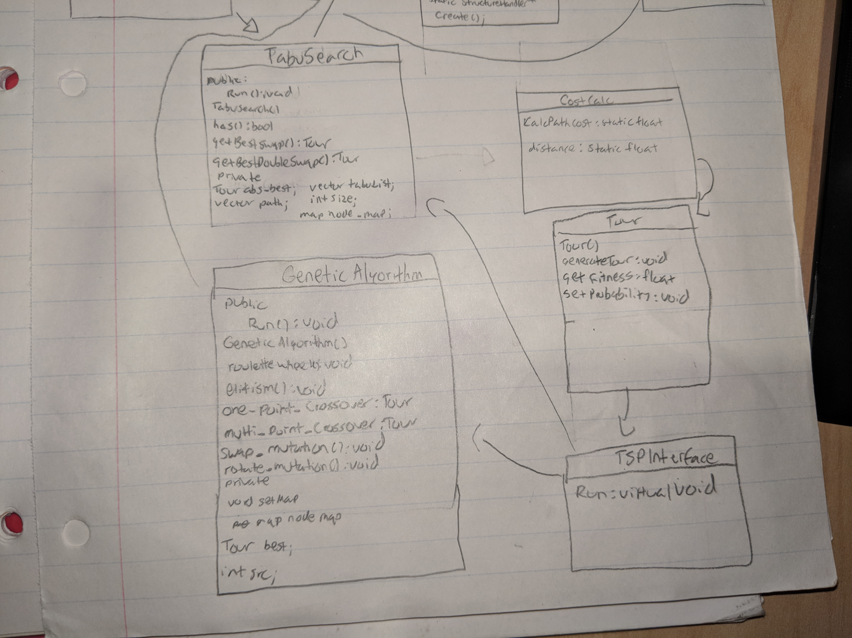

To write this program I used two design patterns for different parts of the program. I used a factory that generates different data structures based on an enum for the File Loading and used the strategy pattern we have been using for the past two labs for the pathfinding algorithms. In addition I also created a Tour class held each path, and used the strategy pattern to choose either a Genetic Algorithm or Tabu Search.

The first part of the program is the StructureHandler, StructureHandler is a pure virtual interface that has one public method to add a line. The purpose of this interface is so you can derive child classes such as MapHandler or something that would manage a vector or linked list and add a line from FileLoader to it. In this program I was only using a Map, so in MapHandler, it inherits from StructureHandler (*Figure 3*) and overrides add line to add the node and position information to a map of an int node and three float position values. It also has another public function called getMap that allows the Search class to retrieve the node map information when the algorithms are being run. The FileLoader inherits from StructureFactory (*Figure 3*) and calls its static Create function to choose a structure to load into. StructureFactory points a StructureHandler pointer to a new child class based upon the enum. In the scope of this program it will point to a new MapHandler. The FileLoader then parses out each line and calls addLine on the structure specified in the StructureFactory. This allows the FileLoader to be able to load a file into any structure of the users choosing as long as there is a handler class for their specific structure. I designed it this way so this file loading code could be reused for other programs that require other data structures.

In this lab I also created a Tour class. This class holds a cost, fitness value, vector path, and a probability. This class was created, so I could abstract all of the mathematical operations done on each path away from the algorithms. This class calculates the fitness and probability, generates random tours, and swaps values in tours.

For the actual searching part of my Traveling Salesman Program, I opted to reuse the strategy pattern from Labs 1 and 2 as the Pathfinding algorithms fit into the design fairly easily. For this pattern everything stems from the Algorithm pure virtual interfaces. For this program I have a Search class that inherits from Algorithm to act as a hub where all the functionality of the program is run through. It also allows each algorithm from PathFinders to be dynamically switched to using function pointers. Search’s load function calls the load function from FileLoader and sets it’s private data member map to what FileLoader returns. It also has to check if it has returned a map as FileLoader could return different types of structures. Execute() just calls the function the function pointer is pointing to, and display() prints out the path. Stats prints out relevant statistics to the project like timing, and the path. Finally save() calls FileLoaders save function. Search in the scope of this project has a TSP Interface pointer that creates a GA or Tabu based on the input to run. The TSP interface has a pure virtual run function inherited by both Genetic Algorithm and Tabu Search. This is just basic inheritance, but I use the TSP Interface pointer to dynamically switch between classes based on the input in main. The strategy pattern was great for this program because it allowed me to have the same complex functionality of past programs (dynamic switching, statistics, and such) while only having to change the searching/sorting algos file to TSPInterface. The main difference between this design and Lab 3’s is I made each algorithm in a different class instead of function. This was done because GA and Tabu have a lot more going on under the hood than BF and Dynamic, so each was given its own class. They were given an interface, so they both could be used in the Search class in a similar way to Lab 3.Additionally, it keeps everything organized very well, and as is the biggest benefit with this pattern it lets me dynamically swap between algorithms on the fly without having to hard code it in main.